Chapter 8
Review exercise: The Aha! response
Identify which Aha! from Dahlen’s Response Continuum best fits Renault’s ‘Crash Dance’ TV advert targeted at German car buying segment and shown in 2007 on German TV?
https://www.youtube.com/watch?v=4ETzgd62Elc
Identify which Aha! From Dahlen’s Response Continuum is best suited to Apple’s ‘iPod’ ad from 2004?
https://www.youtube.com/watch?v=hQw3mVWXncg
Identify which Aha! from Dahlen’s Response Continuum is best suited to the Guinness Surfer Advert below.
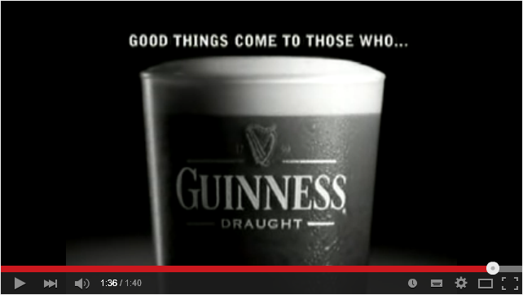
https://www.youtube.com/watch?v=Y9znA_dwjHw
Answers
This advert was produced for TV and cinema for the German market in 2007. It was part of a campaign which also included print and online and which featured French Renault cars achieving a 5 star rating in the Euro NCAP (Safety) Crash Test. By looking at the TV commercial you will see the creative idea used to achieve stand-out and make you attend to the commercial is ‘shock’ as two cars collide with each other to an orchestral piece of background music (there is no voice over, only music). It immediately evokes a response of Ah! That’s different with the end frame moving you along towards an Aha! Response of ‘so that’s what it’s all about!’ By the end frame, you had moved through the continuum and the viewer ‘got it’.
This advert one of a series of adverts produced by Apple which ran from 2004 to 2008. This is the first one and called ‘Silhouette’. It was unique in that no technology firm had used animation and colour like this before. It was dynamic with loud music and yet also showed the traditional technique of a person using the product. Here was a person dancing away to the beat from this piece of revolutionary technology. Previous to this consumers had thought Sony’s Walkman to be revolutionary. Now, Apple’s product and its advertising imagery, helped position the iPOD (and Apple) as being the most up-to-date, appropriate, and innovative technology company. On seeing the advert, the consumer immediately sensed that this was different, and got it immediately i) because of all the pre-publicity and ii) because it showed us how this person was using it. In terms of Dahlen’s Response Continuum, it meant that we got it at the start, and followed through the response continuum – Ha! Wow, this is amazing, followed by Aha! I got it! i.e., I know what that’s all about.
Guinness moved the viewer response from a ‘this stands out’ to understanding by presenting a creative advert that was so novel and creative in its production values (visualisation and tone of voice), and which elicited an immediate appreciation of the artistry and workmanship that went into the endeavour of making it. This makes the advertisement more compelling and memorable, giving the sender added credibility and thus more potency to the originality and meaningfulness of the communication. The viewer’s response was “wow…this is a piece of art” followed by “Ah! That’s so clever!” It’s about wondering, patience and delight – in other words, the emotional journey of anticipating what’s best about this product, and what’s best waiting for. The creative uses a metaphor to ‘hook’ us in ie the Surfer.

